Name: _Nishit Gaurang Shah_

Student ID: 130 176 217 Section: _NGG_

Please read the case study and answer the questions below. This document, in it’s .docx format, must be submitted to Blackboard before the due date. Please not that submitted work, in any other format will not be graded.

You are welcome to use additional tools (example Visual Paradigm) as long as you copy pictures of your work into this document. The pictures must be legible. Your professor will not grade any work that isn’t easy to read.

You are welcome to use outside sources in formulating your answers. Be sure to reference your work using APA format. ***Work not properly referenced will be passed to the Academic Integrity Committee for review.***

Case Study

Brad Dunning runs *Dunning Movers*, a small company that offers moving services to residential and commercial clients.

Brad employs a small team, including some office, movers and drivers staff. A few times a year, Brad attends trade shows and visits manufacturers to learn about new packing supply products and moving equipment.

Your team has been hired to document Brad’s requirements and recommend software for Brad to purchase.

Your team has started looking at Brad’s financial records and found that Brad categorizes his income transactions by client. For expenses, he records the supplier’s invoice number, the amount and the date of the expense.

Your team leader has written the following scenarios to capture Brad’s requirements.

|  |  |  |  |
| --- | --- | --- | --- |
| Use Case Name | Record Income Transaction | | |
| Triggering Event | Client pays for work done | | |
| Brief Description | Allows the Owner to record an income transaction | | |
| Actors | Owner | | |
| Related Use Cases |  | | |
| Preconditions | Owner has opened the Main Menu. | | |
| Post Conditions | Income transaction is recorded | | |
| Flow of activities | Actor | | System |
|  | 1. | Requests to record an income transaction | Displays a list of clients and prompts for selection. Prompts for amount of transaction and transaction date (defaults to the system date) |
|  | 2. | Selects a client, enters date and amount | Displays the transaction and prompts for confirmation |
|  | 3 | Chooses to confirm | Saves the transaction. |
| Exception Conditions | * Owner chooses to cancel recording income transaction. | | |

|  |  |  |  |
| --- | --- | --- | --- |
| Use Case Name | Query Expense transactions | | |
| Triggering Event | Owner requires a list of expenses | | |
| Brief Description | Allows the Owner to review expense transactions | | |
| Actors | Owner | | |
| Related Use Cases |  | | |
| Preconditions | Owner has opened the Main Menu. | | |
| Post Conditions | Expense transactions retrieved | | |
| Flow of activities | Actor | | System |
|  | 1. | Requests to query expense transactions | Prompts for start and end date |
|  | 2. | Enters a start and end date | Retrieves expense transactions that meet the date requirements. Displays the list |
| Exception Conditions | * Owner chooses to cancel querying expense transactions. | | |

Question 1 (worth 10 marks)

Complete a class diagram to support what your team has learned so far about *Dunning Movers.*

**Answer 1:**

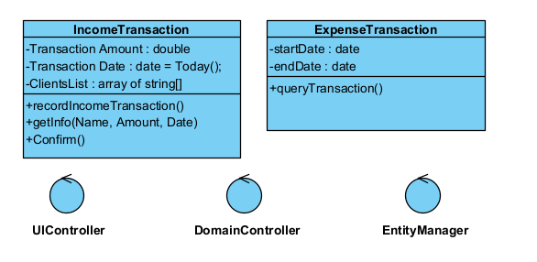

Question 2 (worth 20 marks)

Complete sequence diagrams to support the above scenarios.

**Answer 2:**

**1:**

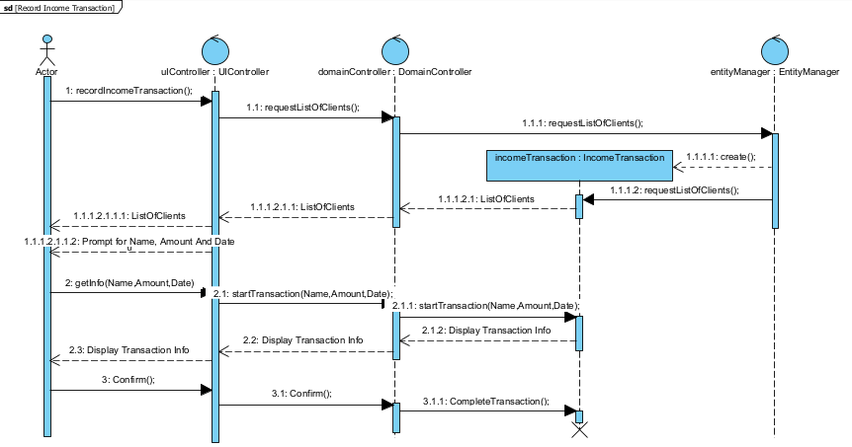

**2:**

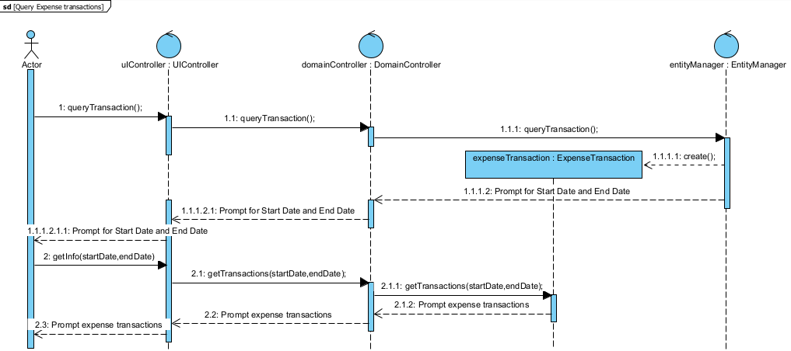

Question 3 (worth 3 marks)

Brad’s having a hard time keeping track of documents and would like to record where he’s stored his supplier’s invoices with each expense transaction. He’s committed to scanning any physical invoices received in the mail. How would you change you model to support the electronic location of documents for each expense? Please describe in English.

**Answer 3**

**If Brad is having problem with keeping track of documents and store supplier’s invoices, I will make a new class called INVOICE. This class will be connected to both ExpenseTransactions class and IncomeTransaction class by invoiceNumber. The class INVOICE will have all the records of invoices and transactions. Now if some one have to get Expense Transactions between two dates, I will just get this class and get done with it.**

Question 4 (worth 3 marks)

Brad’s been approached to provide services for a client who resides on Georgina Island Reserve. This client has tax exempt status as part of belonging to Indigenous people. What are tax implications? Does this affect your model?

**Answer 4:**

**I really don’t have much information about the tax exempts. In my model, I did not focus on the tax implications. I will talk to Brad and hire someone to deal with the tax. This actually doesn’t affect my model. I will make a new class which manages the tax and activate it every time the transaction method is called.**

Question 5 (worth 3 marks)

One of Brad’s clients pays him in USD. What should Brad do? How could you change your model to support this?

**Answer 5:**

**Brad should accept the payment so they can grow in international business as well. I will ass a method called currency exchange in my model. If any other type of currency will be paid, I will convert it into mine and deposit it in the bank.**

Question 6 (worth 3 marks)

Brad is a small business owner. Some of his clients have asked if they pay cash, can they avoid paying tax? Is this a good idea for Brad? What about his clients?

**Answer 6:**

**No, no, no. I won’t accept the cash. If they are so eager to pay in cash I will find them new suppliers. In that way, I will make new connections in my field and my customers will be happy too.**

Question 7 (worth 3 marks)

*Dunning Movers’* project is documenting the business’s requirements for a new system. We’ve looked at Agile and Waterfall (Predictive) Project Management methodologies. You are a team of 3 analysts and a Project Manager. If you were the Project Manager, what Project Management Methodology would you use for this project? And why?

**Answer 7:**

**In my capacity as a project manager, I'll employ Agile project management. Because if adjustments to our system are required, we will be able to make them quickly thanks to this. Since this will be a small firm and the owner might not know all of his requirements at first, it would be simple for us to add more functionalities to our system if he requested them. We will have the opportunity to significantly improve our software with each release.**